Create an SNS Topic
Step 1: launch an instance with the name tag 'instance'.
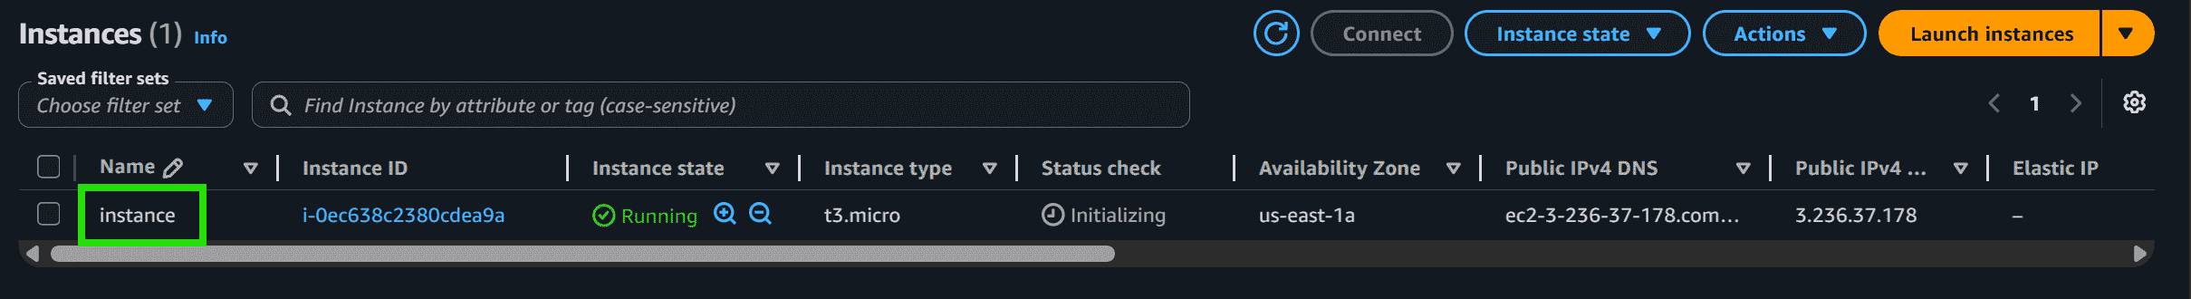
Step 2: Go to SNS topic dashboard and click on create a topic.
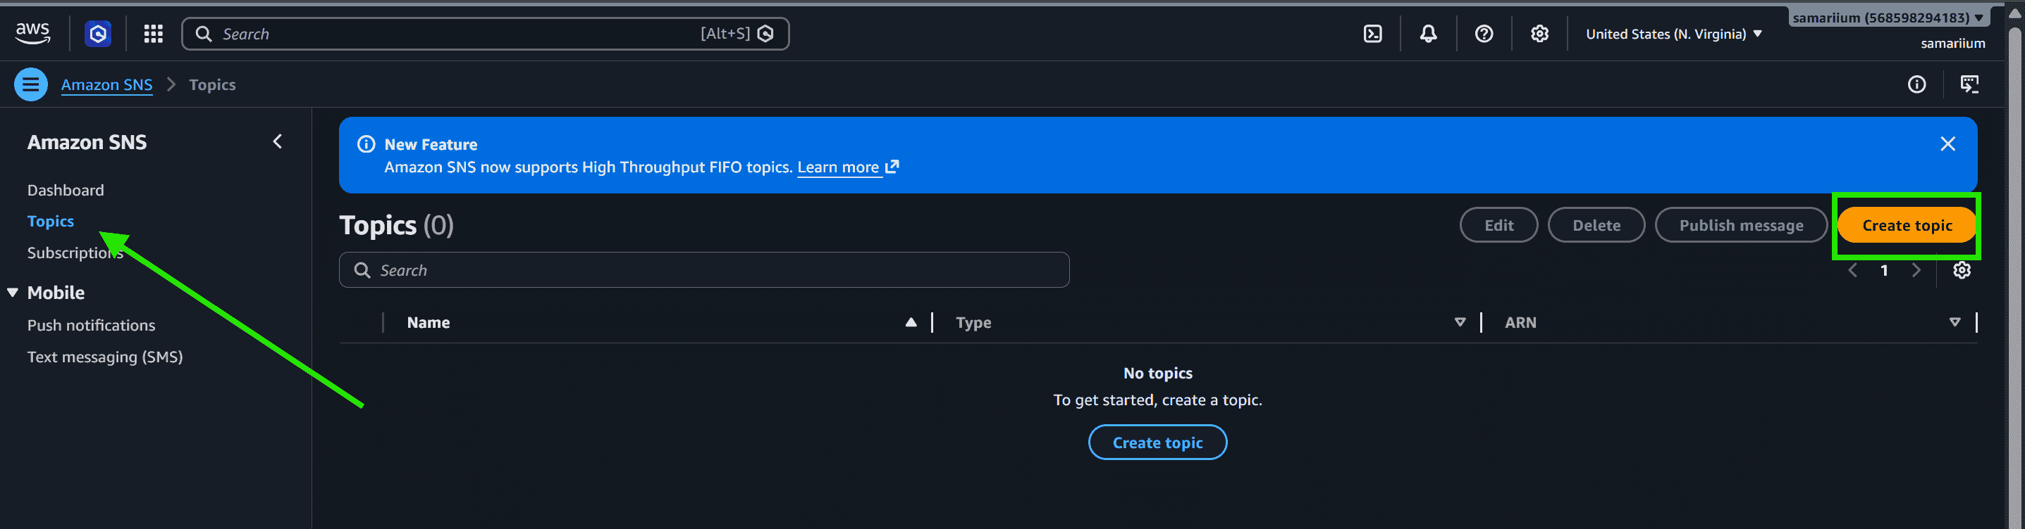
Step 3: You will be redirected to the dashboard. Enter the topic name and display name, then scroll down and click on Create topic.
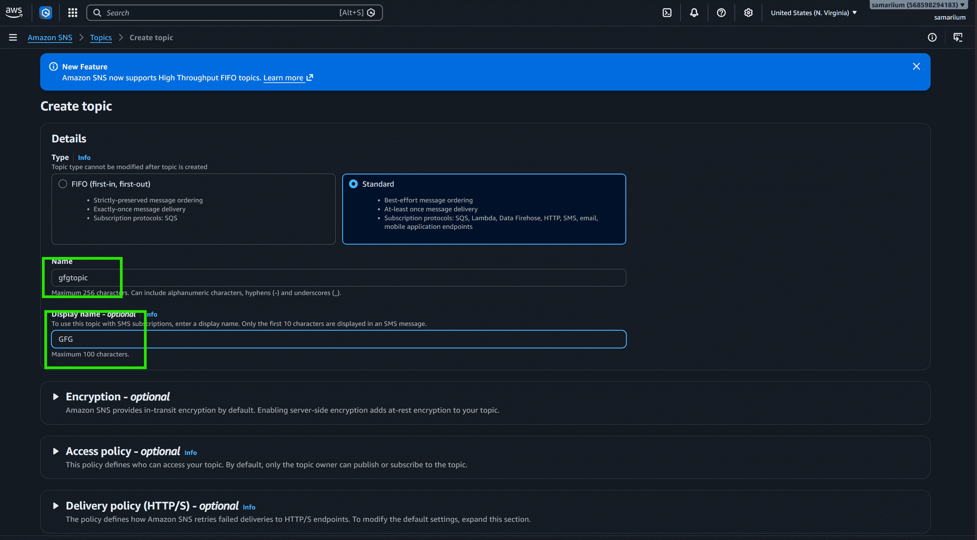
Step 4: The SNS topic is created successfully.
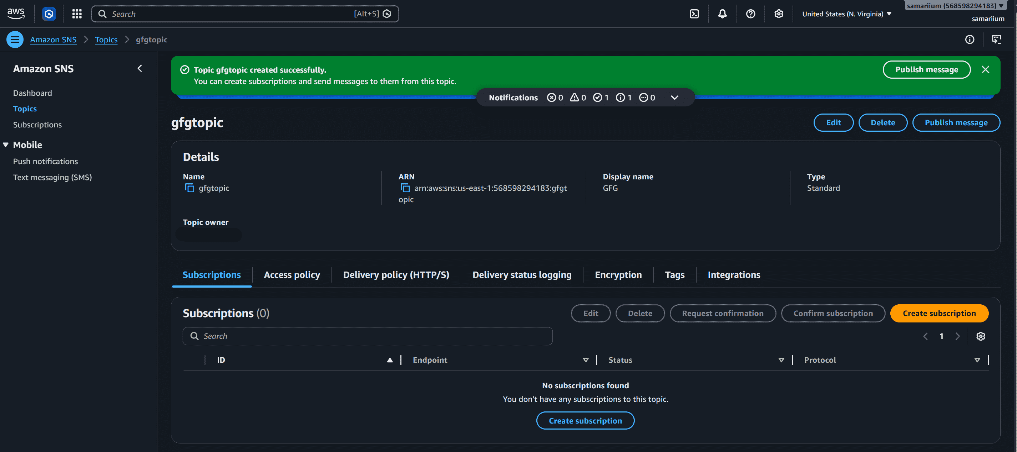
Add Subscribers
Step 1: Go to the SNS Topics dashboard, click on the gfgtopic link, and under the Subscriptions section, click on Create subscription.
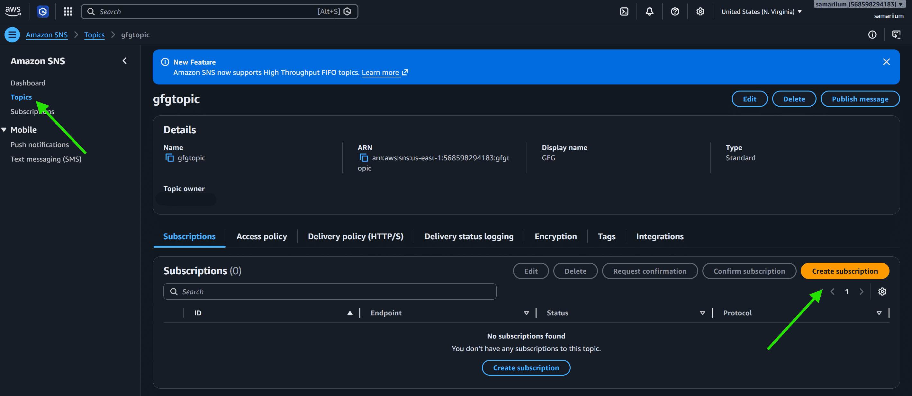
Step 2: Select Email as protocol and specify the email address of subscribers in Endpoint. Click on create the subscription. Now Go to the mailbox of the specified email id and click on Subscription confirmed.
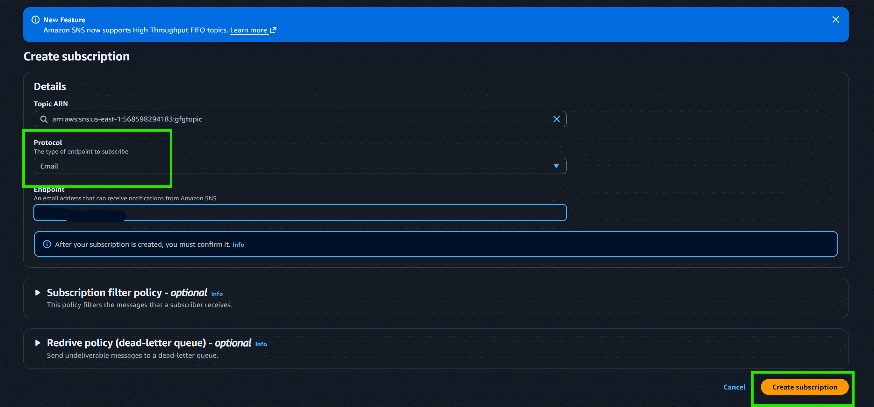
Craft the CloudWatch Alarm
Step 1: Go to the CloudWatch dashboard on the AWS management console. Click on Metrics in the left pane.
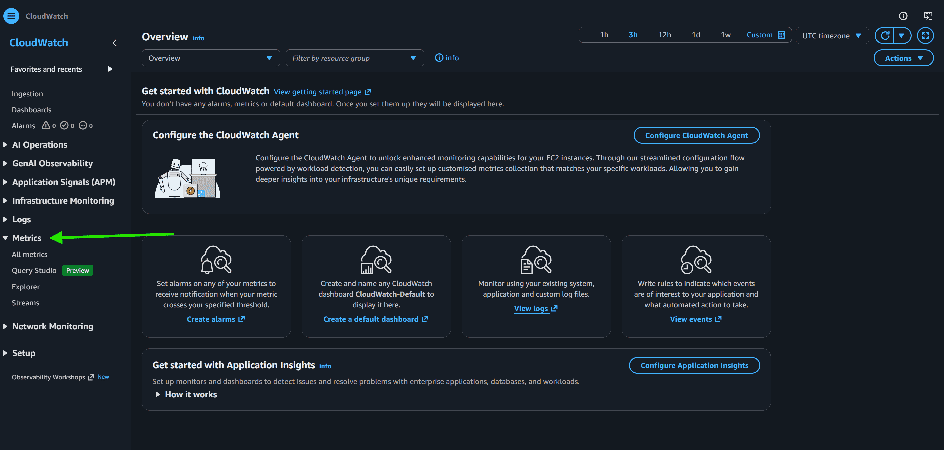
Step 2: In All metrics section click on EC2
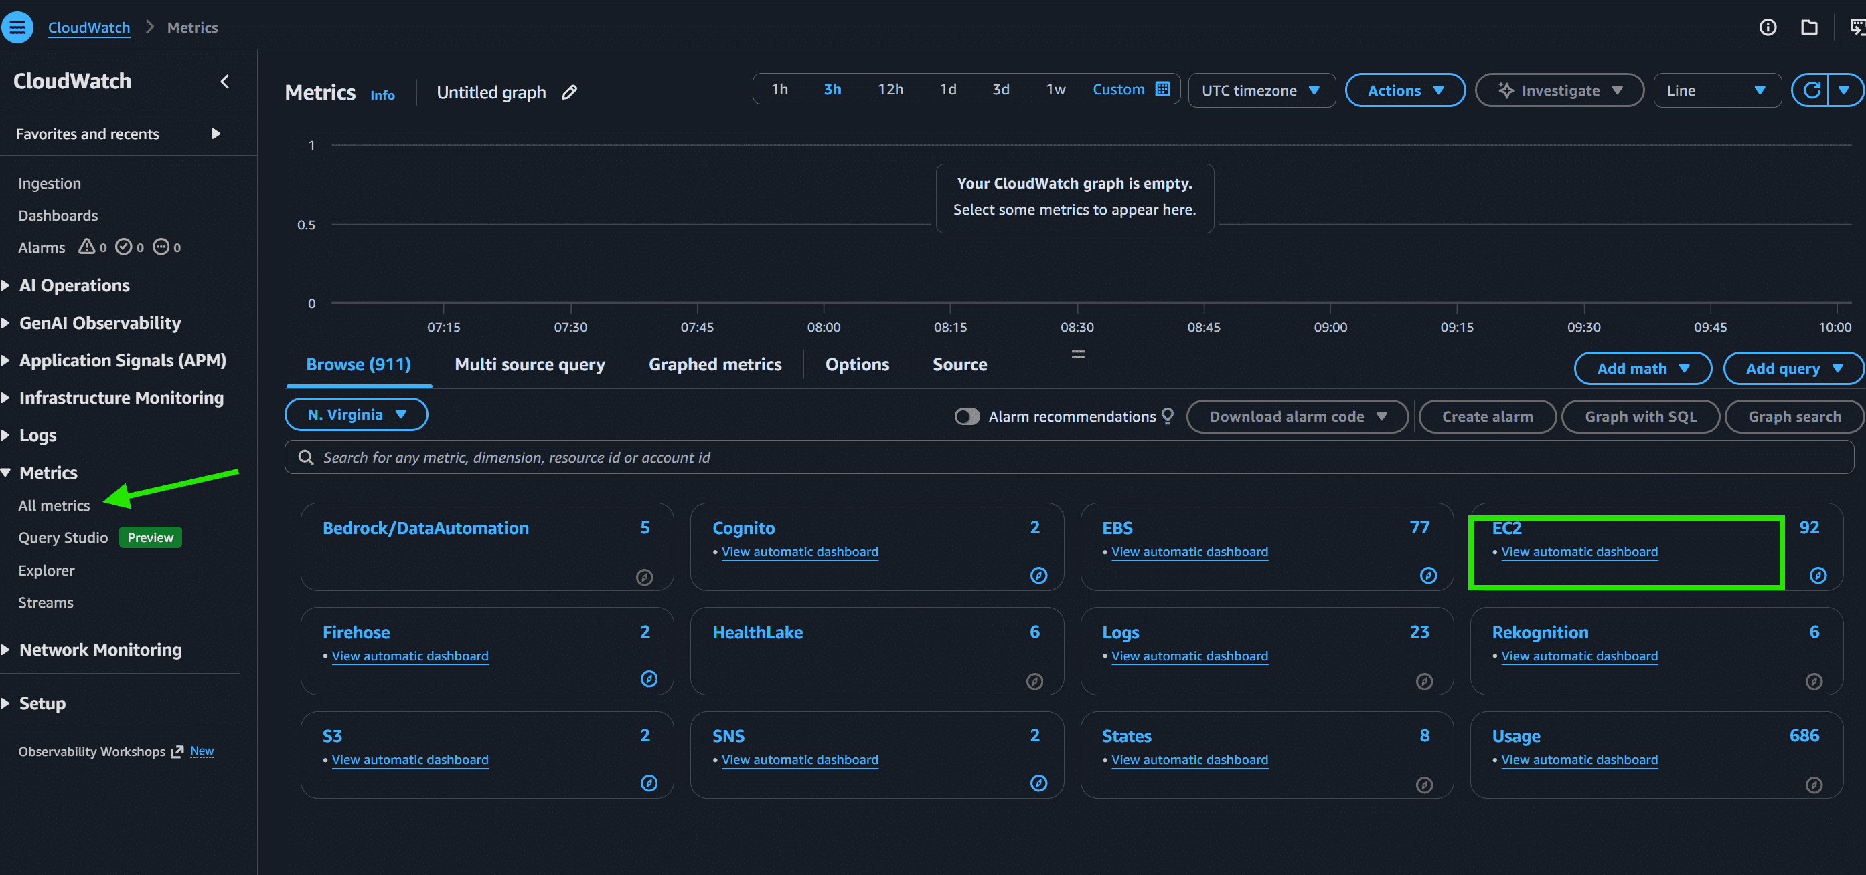
Step 3: Click on Per-instance metrics.
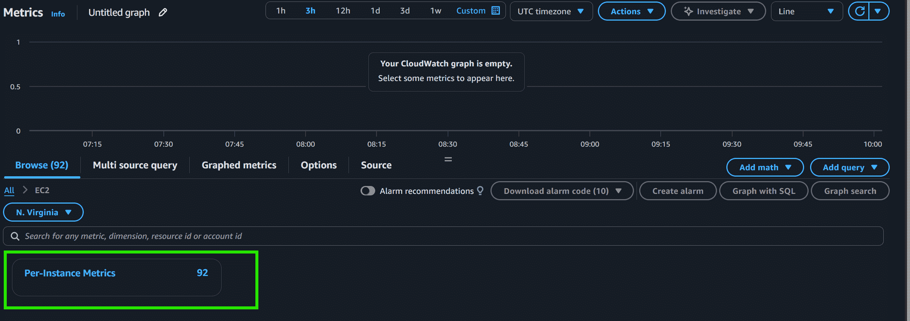
Step 4: Select the instance you launched with Metric name CPUUtilization.
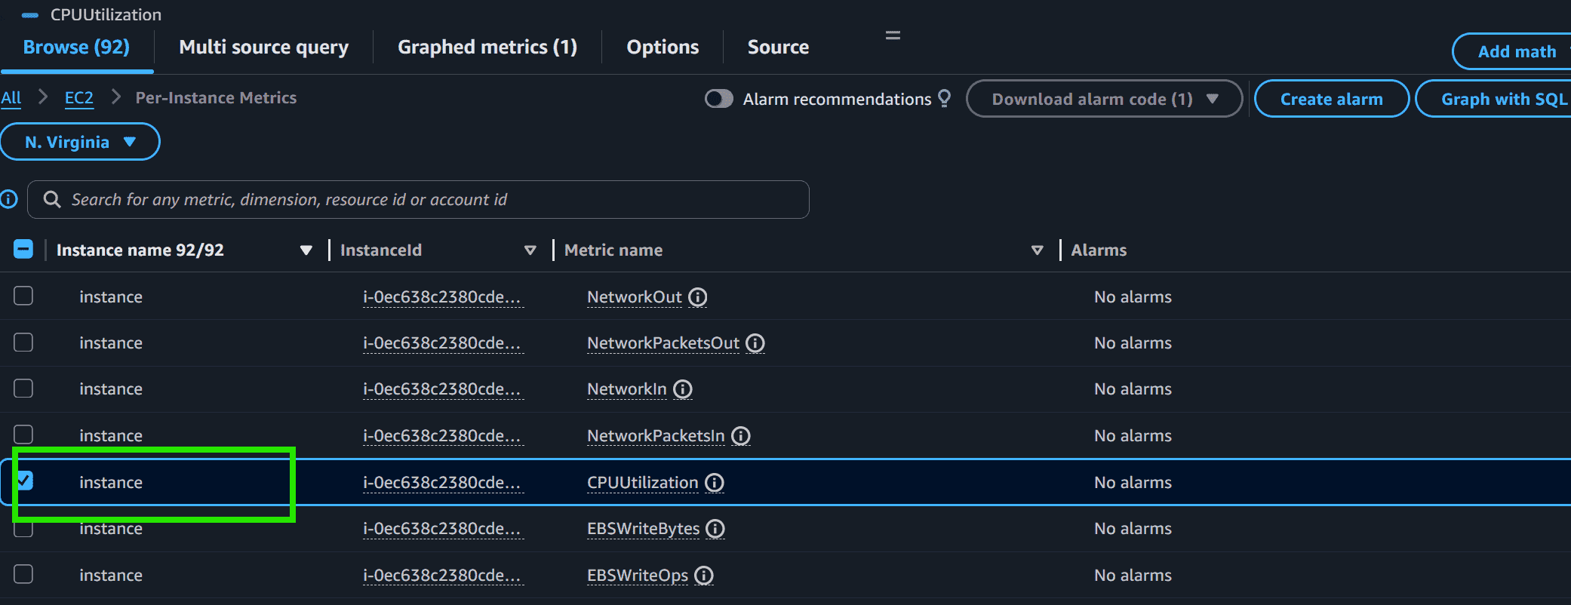
Step 5: Go to Graphed metrics, click on the bell icon.
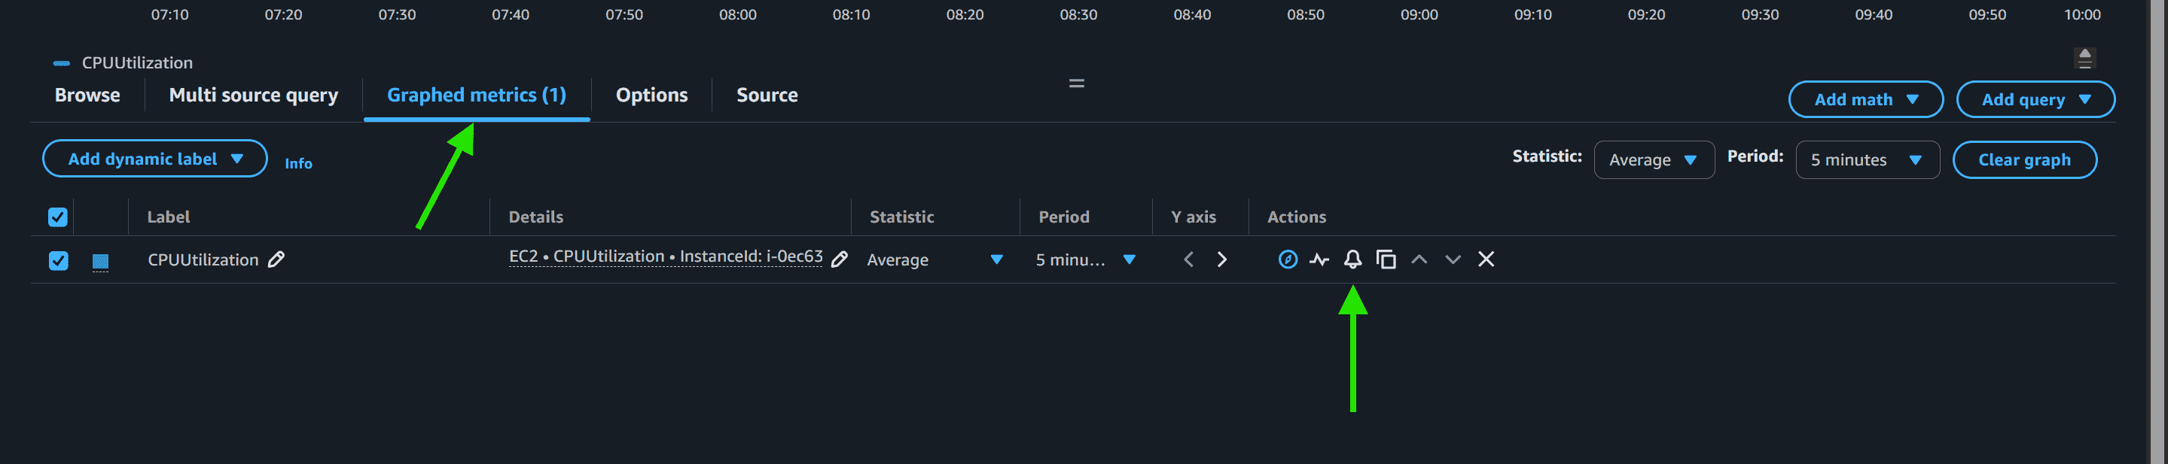
Step 6: This dashboard shows the components of Amazon CloudWatch such as Namespace, Metric Name, Statistics, etc.
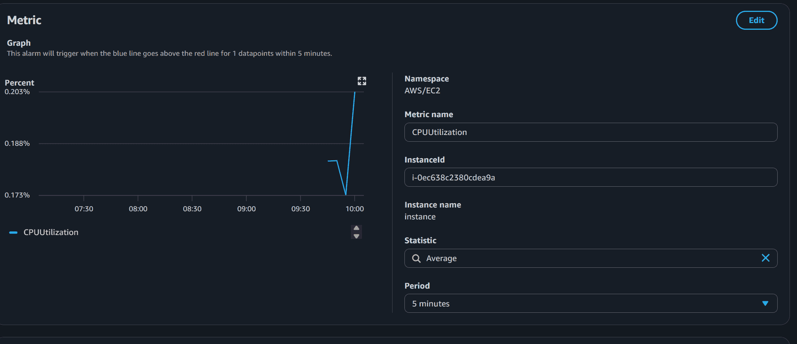
Set the Threshold
Step 1: Select the greater threshold. Also, specify the amount( i.e. 80 ) of the threshold value. Click on Next.
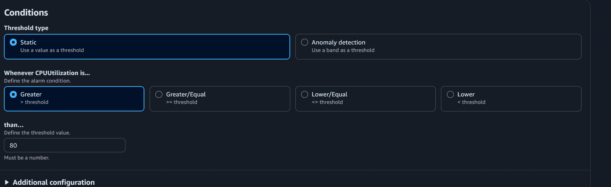
Connecting
Step 1: Click on Select an existing SNS topic, also mention the name of the SNS topic you created now.
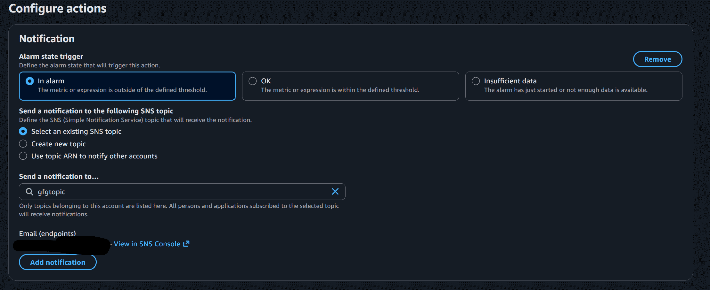
Step 2: Specify the name of alarm and description which is completely optional. Click on Next and then click on Create alarm.
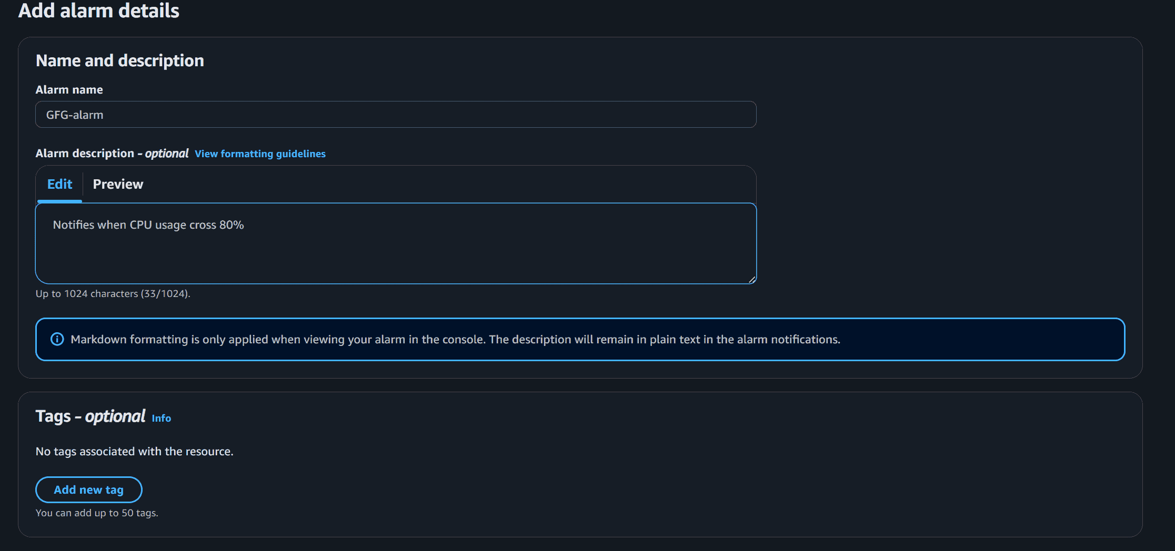
Step 3: The alarm is successfully created.
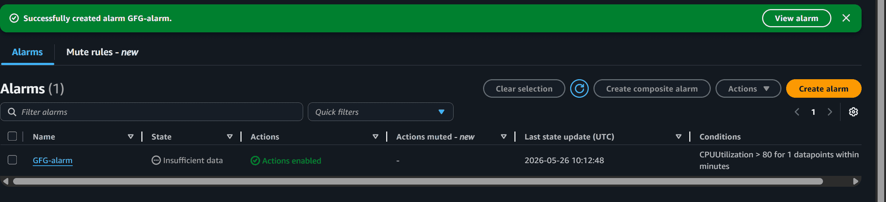
Step 4: You can see the graph which notifies whenever CPU utilization goes above 80%.
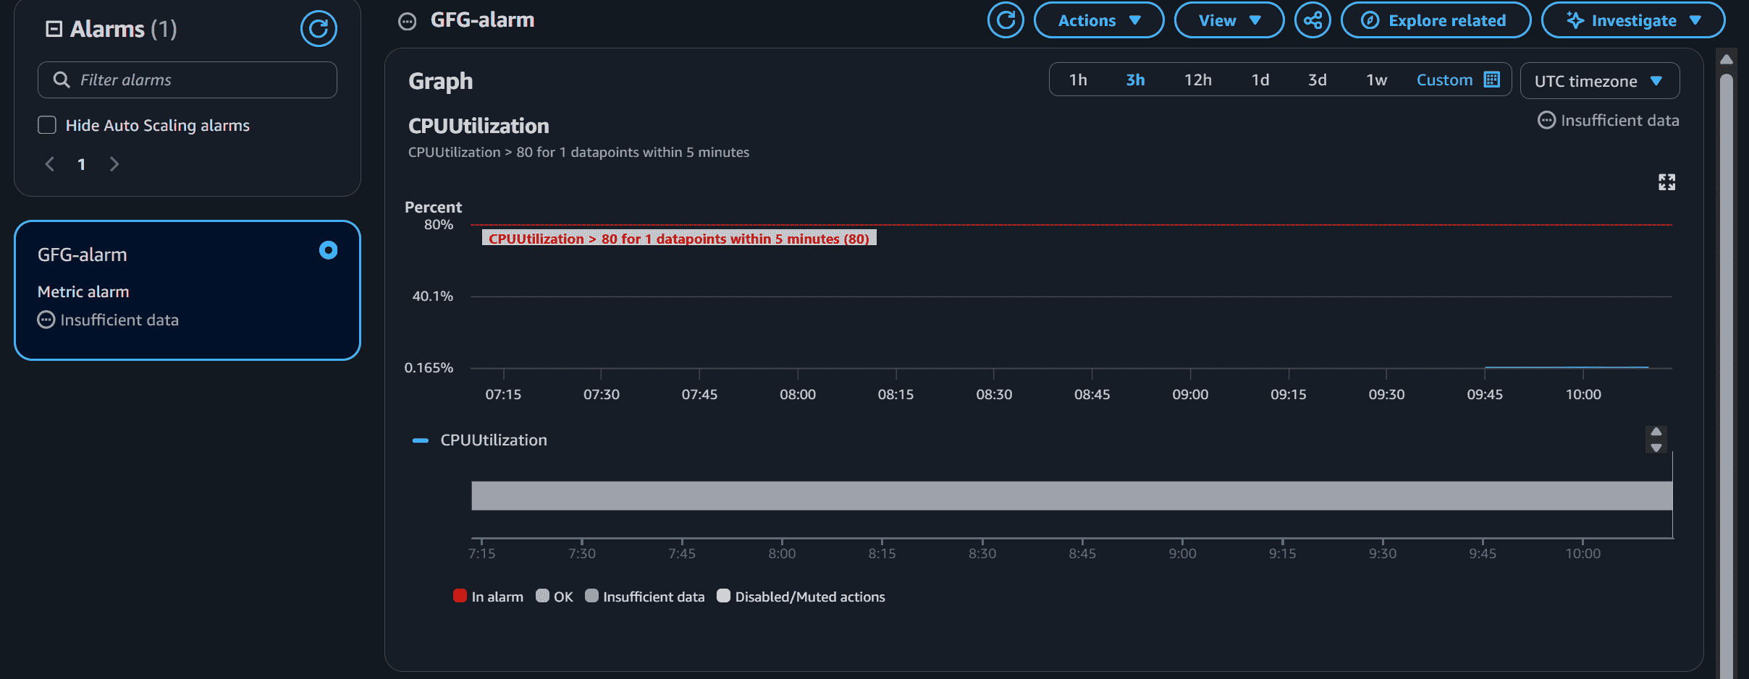
Creating a dashboard in Amazon CloudWatch
Creating a dashboard in Amazon CloudWatch is a straightforward process that allows you to visualize and monitor metrics and logs in a centralized and customizable view. Here's a step-by-step guide on how to create a dashboard in Amazon CloudWatch:
Step 1: Access Amazon CloudWatch Console
- Open the Amazon CloudWatch Console.
Step 2: Navigate to Dashboards
- In the CloudWatch Console, locate the "Dashboards" section in the left navigation pane.
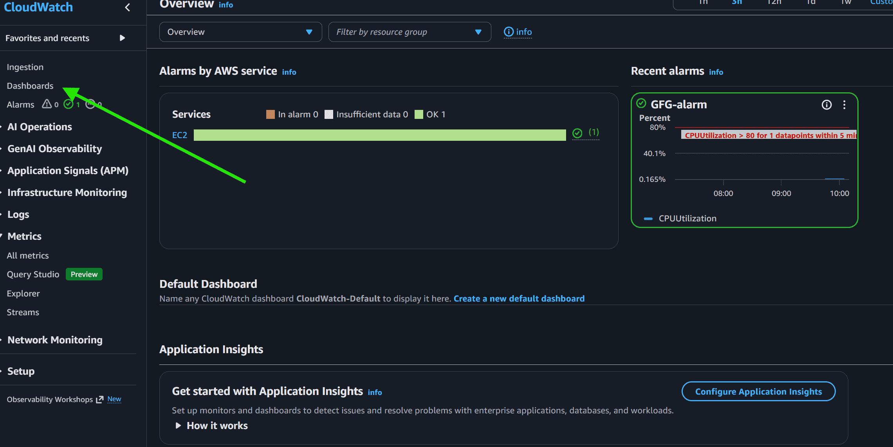
Step 3: Click "Create Dashboard"
- Click the "Create dashboard" button to start the dashboard creation process.
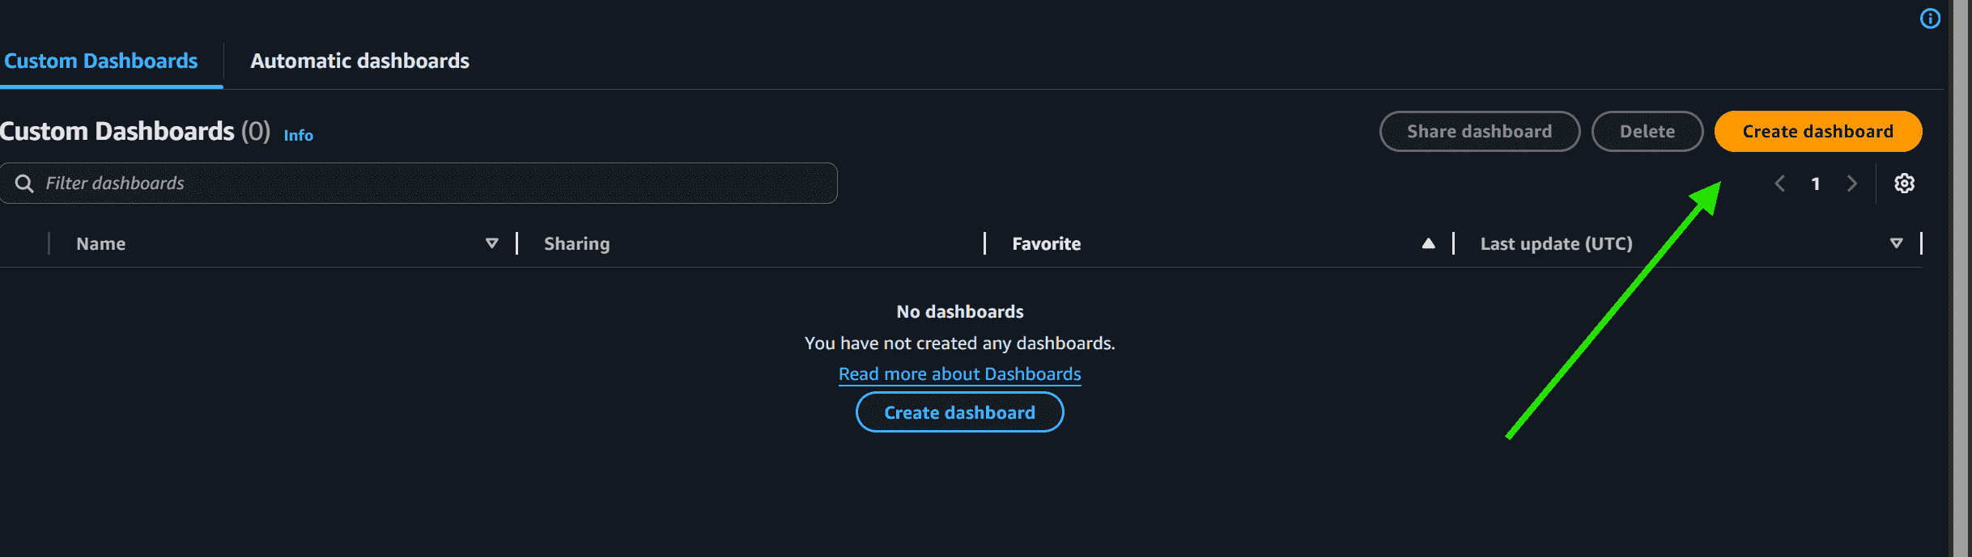
Step 4: Enter Dashboard Details
- Provide a name for your dashboard in the "Dashboard name" field. Optionally, you can also add a description.
Step 5: Add a Number Widget for CPU Utilization
- Click on Add widget.
- Select the Number widget type.
- Enter the widget name as CPU Utilization.
- Choose EC2 under Namespace.
- Select Per-Instance Metrics.
- Choose CPUUtilization as the metric.
- Configure additional settings if needed and save the widget.
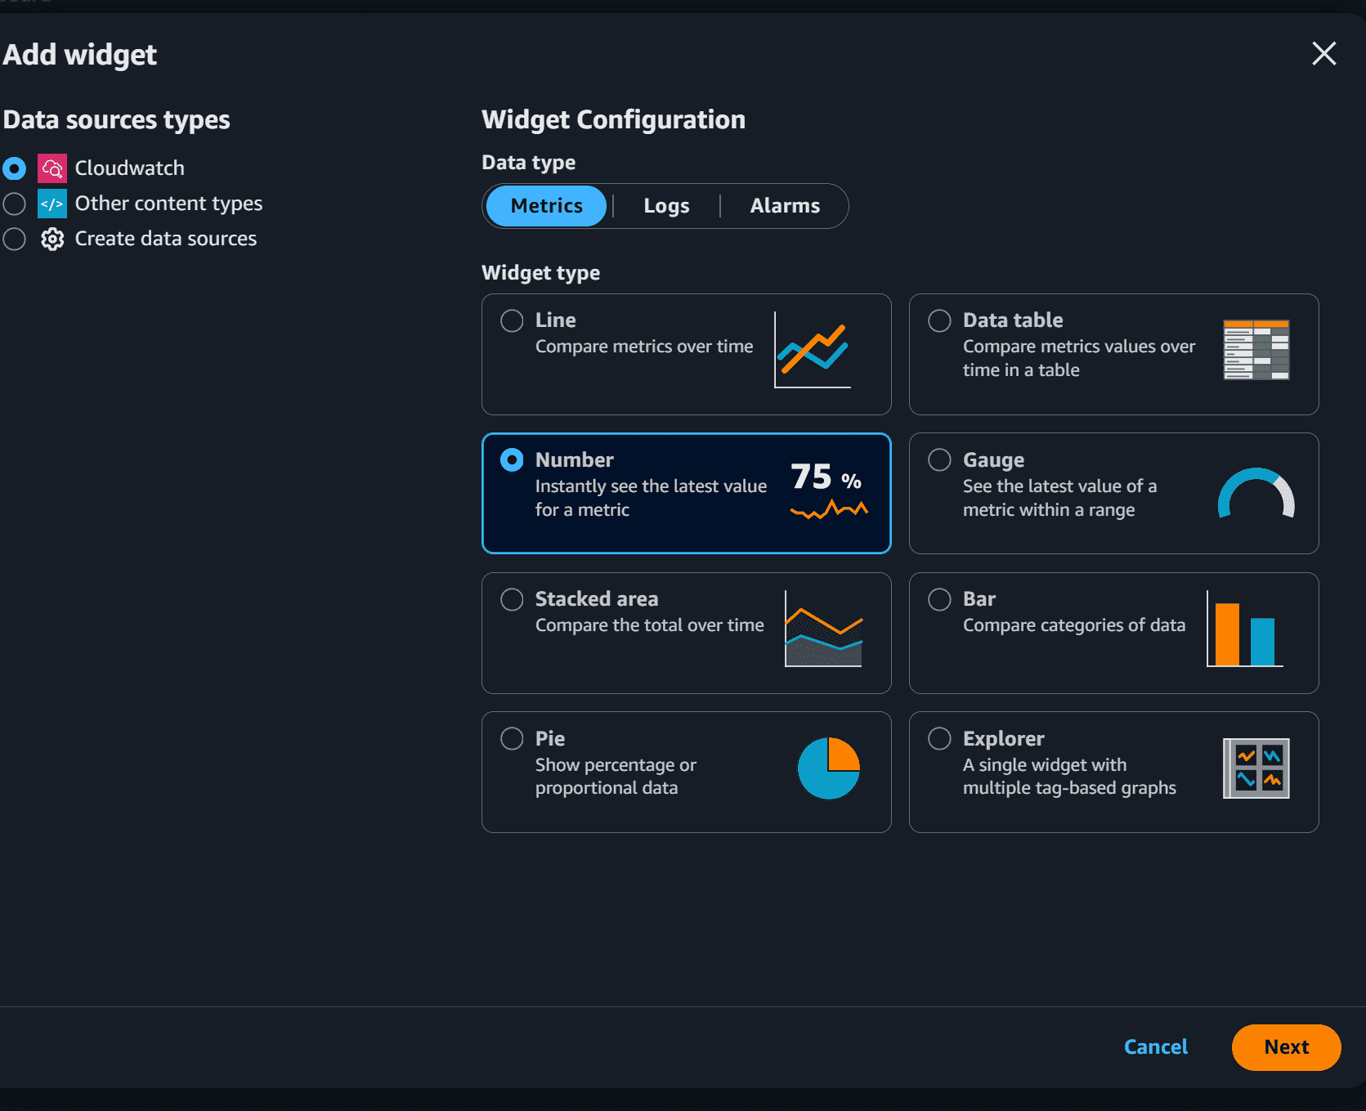
Step 6: Save the Dashboard
- Once you've configured the widget, click the "Create dashboard" or "Save dashboard" button to save your changes.
Step 7: View the Dashboard
- Your dashboard is now created with a Number widget displaying the CPU utilization of your EC2 instances. You can view it in the CloudWatch Console.

